OMKAR SHINDE

BANKING SYSTEM

ABSTRACT

The **BANKING INDUSTRY** is one of the most essential financial pillars of the financial sector, and it is critical to the economy’s functioning. It is critical for a country’s economic development that its trade, industrial, and farm funding needs are handled with greater commitment and responsibility. As a result, a country’s progress is inextricably related to the development of banking. In today’s economy, banks should be viewed as development leaders rather than money merchants. They play a crucial role in deposit mobilization and credit disbursement to many sectors of the economy.

The **Reserve Bank of India (RBI)**, commercial banks, cooperative banks, and development banks comprise India’s banking system (development finance institutions). The core of India’s financial system is these institutions, which serve as a meeting point for savers and investors. Banks play a vital role in the development of poor countries by mobilizing resources and efficiently allocating them.

**The importance of banking system in India**

* Insufficient capital formation makes economic development difficult in a country. Commercial banks are encouraging individuals to save their money and mobilize it for beneficial uses at this time.
* Credit creation boosts output, boosting economic growth and, in turn, creating a large number of job prospects.
* Commercial banks promote balanced regional development in India by providing the required financial infrastructure and money to backward areas.
* By providing timely loans to agricultural farmers, commercial banks aid in the promotion of the primary sector.
* They offer advanced loans to consumers for the purchase of assets such as residences, consumer goods, and furniture, among other things, and they encourage individuals to pursue a higher level of living.
* The banking sector plays a significant part in the Indian economy, as commercial banks support the Indian government in achieving each aim of the country’s planned economic development.
* For both internal and external trade, commercial banks offer the necessary financial backing and infrastructure.

OBJECTIVE

* The tabular representation will help Indian Banks to keep organised database, that will provide a detailed overview about authorities belonging to a distinct department and the associated banking functions handled by them.
* Currency and their associated serial numbers play a vital role in segregating their transaction paths and allocated standardized distribution this structured data will help keep a track of journey from currency print to currency distributed.
* Every city has its own bank that provides economic assistance to individuals in such a hustled and complex working environment its crucial to have an ordered and managed data that will keep currency flow on record.
* **RBI ( RESERVE BANK OF INDIA)** is a centralized bankers bank associated with a lots of rural and commercial banks , providing funds and stating rules and regulations for banks.
* **SBI** being the financial powerhouse having the maximum branches all over INDIA needs an updated record of cash inflow which should be updated from time to time , for this purpose an organised user database provides efficient assistances for records management.
* Inventory or Chambers holding a large sum of currency and valuable property counted in digits which keep changing over the course of time ,to have a editable database that is easy to update and add on to is a basic requirement of inventory management

.

STRUCTURE OF TABLES

RESERVE BANK OF INDIA

This table represents various departments in **RBI** and the department heads their age along with a special **ID** that is unique and distinguished , it’s also a key that helps detect the manager name as well as his specialised department , every member a part of this table holds an authorized responsibility of their particular field and have licence to govern and regulate banking functions.

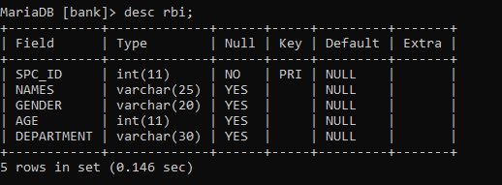

CURRENCY NOTE PRESS

This table represents the tabular representation of **CNP** where currency notes are printed , as we saw earlier **RBI** have specialised authorities who govern and regulate various banking functions one of which is **CURRENCY DEPARTMENT**  this department is responsible for cash intake from CNP and cash outflow to other banks ,this table shows the number of notes of **5000 & 2000** printed along with their unique serial number the city in which they will be regulated along with management officers name and distinct ID who sanctions these notes.

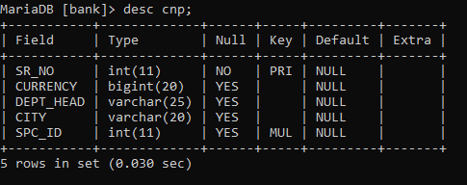

CIRCULATION

Now the printed notes are circulated to various banks associated with **RBI** , this tabular data systematically represents the banks with their bank ids in which the notes are going to be circulated along with the manager in charge and the note serial number making it convenient to track the currency and its churning process.

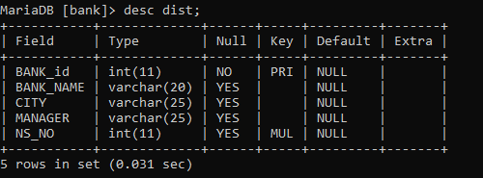

STATE BANK OF INDIA

STATE BANK OF INDIA (SBI) is one of the eminent banks of INDIA setting a prominent bench mark , this table shows organised representation of SBI banks three important segments managed by officers along with bank ids , a special chamber id allocated to different chambers of these banks is also mentioned.

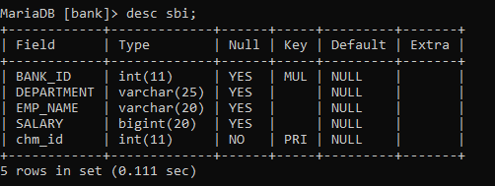

CHAMBERS

Chambers a safe place where all sorts of currency and valuable assets are stored ,each bank has its chambers and to manage these chambers this table can be used ,the currency and gold who’s quantity and count keeps changing everyday needs a record to be maintained this record is maintained in this table.

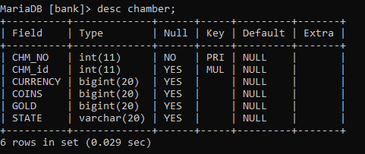

CONTENTS OF TABLES

RBI

**RBI**  being a responsible banking firm handling a lot of complex duties assigned to different individuals needing a unique identification id used to identify them and their assigned department , making it a tabular database a primary need to keep and maintain these records which can be used and updated whenever necessary ,below table shows different officers belonging to different departments with their unique ids.

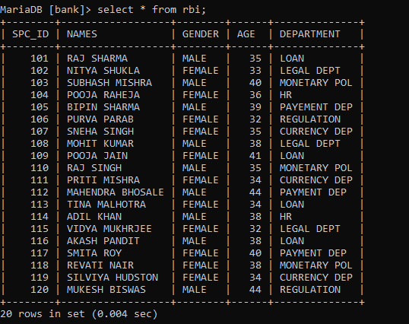

CNP

**CURRENCY NOTE PRESS** , printing a large set of currency with unique serial numbers then getting sanctioned and circulated among banks needs a well organised database that keeps records of these notes and currency outflow for this purpose following table is used.

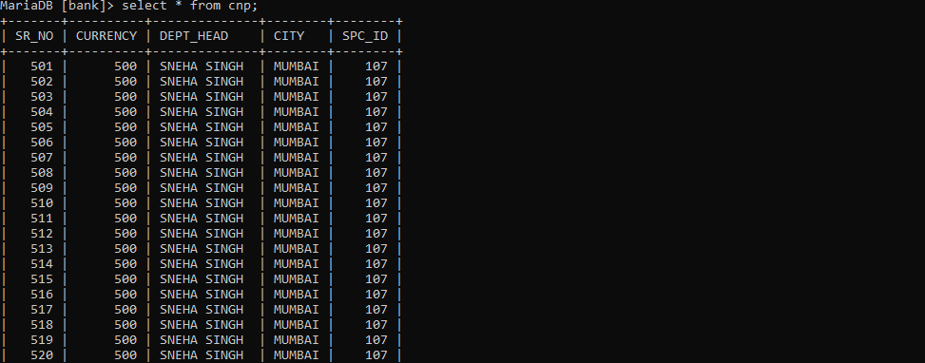

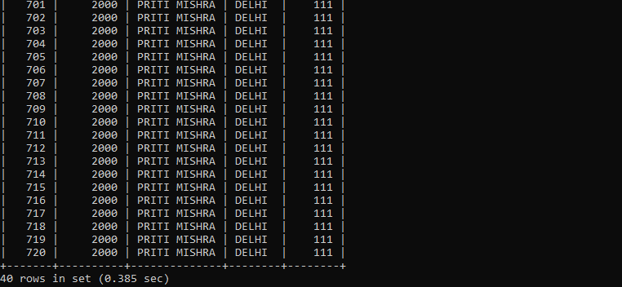

DIST

Distribution of the currency from CNP to the banks is a process performed with utmost care and discipline the notes circulated among banks are segregated using their serial numbers , following table shows different banks with their bank ids and notes circulated among them , every state have their own banks and each bank is supplied with a set of currency that is then brought into circulation as per requirement.

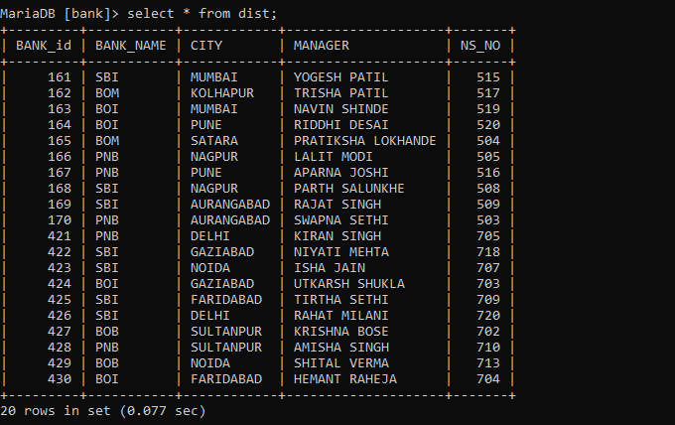

SBI

SBI having a wide spread of banking facilities not online in INDIA but also in foreign countries have a complex structure that involves frequent changing data in such case the data should be managed and be able to update easily making it possible to have on records regarding cash inflow and outflow ,various departments performing banking operations are stated along with the chamber ids used to identify inventory allocation.

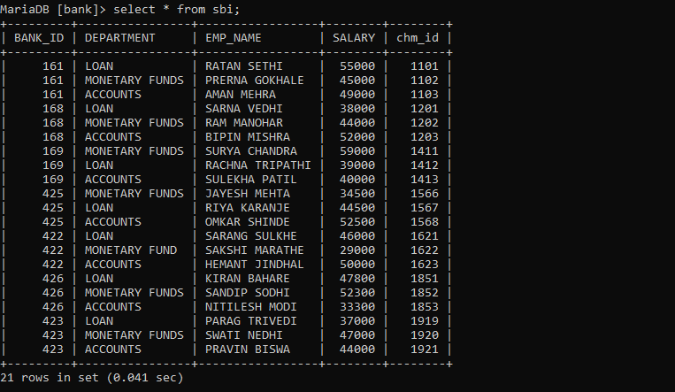

CHAMBERS

Chambers or inventories used to stack currency and valuable assets held by bank, which belong to either public or the bank treasury , keeping a count of these assets is very important and crucial task of the bank which requires a proper database that can be updated regularly and efficiently.

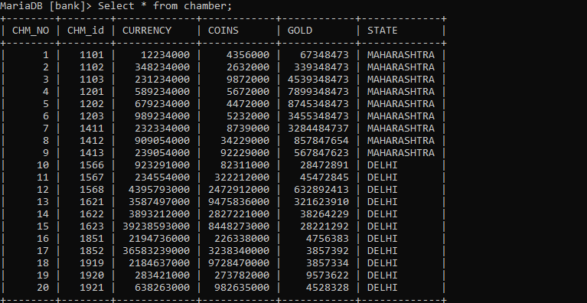

QUERIES

* 1. Show employee details working in RBI who belong to the LOAN dept. with ages above 32.

MariaDB [bank]> select * from rbi where department='loan' group by names having age>32;

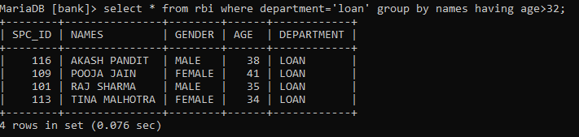

* 1. Count the number of 500 and 1000 notes printed by CNP group by departmental heads and city.

MariaDB [bank]> select dept_head,city,currency,count(sr_no) from cnp group by dept_head,city;

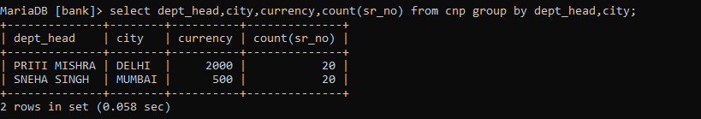

* 1. Select distribution details of SBI from distribution table in bank id’s ranging between 161 and 170.

MariaDB [bank]> select * from dist where bank_id between 161 and 170 and bank_name='sbi';

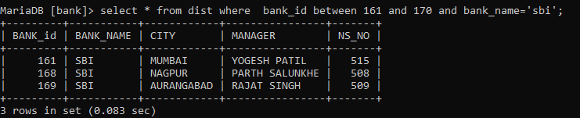

* 1. Add DIWALI bonus to salaries of employees from loan department by 15%.

MariaDB [bank]> select department,emp_name,salary + (salary * 0.15) as'DIWALI BONUS' from sbi where department='loan' group by department,emp_name;

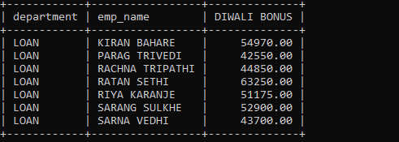

JOINS

1. Combine SBI & DIST table to derive employee names belonging to departments with their associated bank_ids

MariaDB [bank]> select sbi.bank_id,sbi.emp_name,sbi.department,dist.bank_id from sbi inner join dist on sbi.bank_id=dist.bank_id;

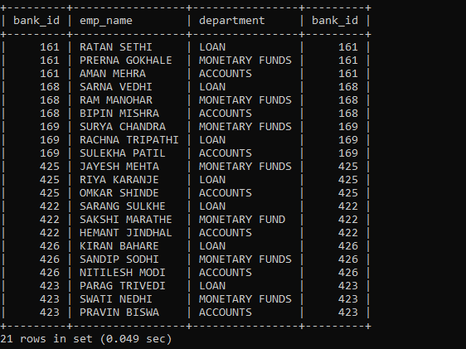

1. Combine DIST & SBI table to derive distribution data along with data corresponding to SBI.

MariaDB [bank]> select sbi.bank_id,sbi.emp_name,sbi.department,dist.bank_id,sbi.salary from sbi right join dist on sbi.bank_id=dist.bank_id;

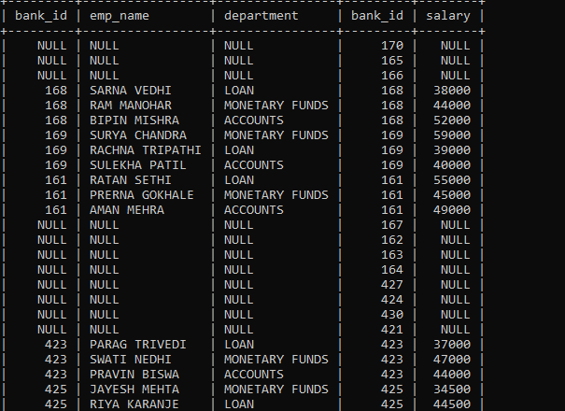

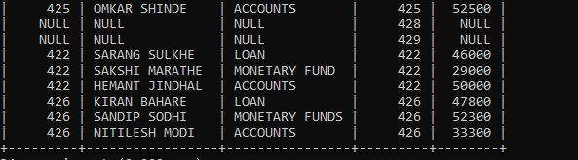

1. Combine chamber and SBI table to retrieve chamber details associated to officers and the currency held by each chamber

MariaDB [bank]> select sbi.bank_id,chamber.chm_no,sbi.emp_name,chamber.chm_id,chamber.currency from chamber join sbi on sbi.chm_id=chamber.chm_id;

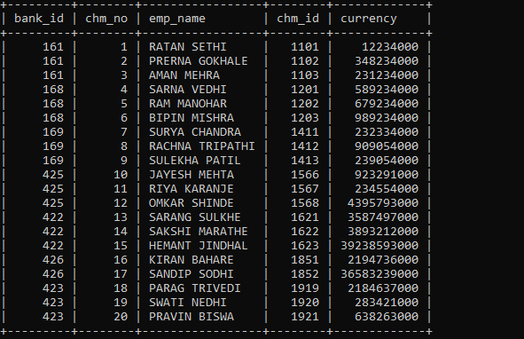

1. Join chamber and SBI table to enlist total gold worth in each chamber associated to each SBI bank.

MariaDB [bank]> select sbi.bank_id,chamber.state,sbi.emp_name,chamber.chm_id,chamber.gold from chamber join sbi on sbi.chm_id=chamber.chm_id;

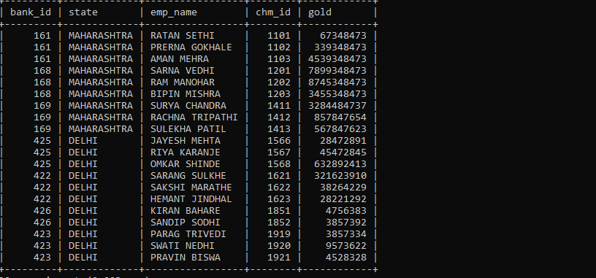

VIEWS

1.Create a view of RBI table with employee details associated to spc_ids from 101 to 110.

MariaDB [bank]> create view rbi_v2 as select * from rbi where rbi.spc_id between 101 and 110;

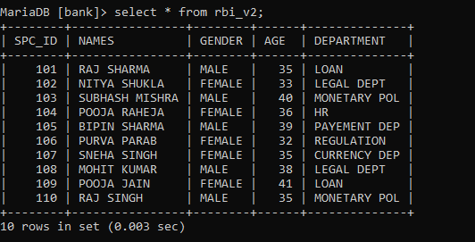

2. Create a view of SBI table of employees having salaries in range 3000 and 5000 with their corresponding details.

MariaDB [bank]> create view sbi_v as select * from sbi where salary between 30000 and 50000;

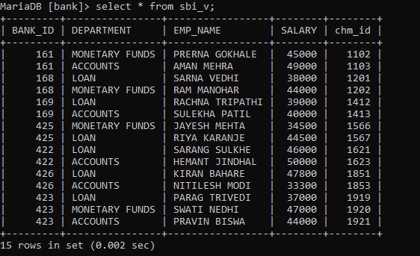

3. Create a view of distribution table where SBI bank managers enlisted along with the bank details.

MariaDB [bank]> create view dist_view1 as select bank_id,bank_name,city,manager from dist where bank_name='sbi';

